**MANDATORY EXERCISES**

**Exercise 1: Control Structures**

**Scenario 1:** The bank wants to apply a discount to loan interest rates for customers above 60 years old.

**Question:** Write a PL/SQL block that loops through all customers, checks their age, and if they are above 60, apply a 1% discount to their current loan interest rates.

SET SERVEROUTPUT ON;

CREATE TABLE customers (

customer_id NUMBER PRIMARY KEY,

name VARCHAR2(100),

age NUMBER,

balance NUMBER,

IsVIP VARCHAR2(10)

);

CREATE TABLE loans (

loan_id NUMBER PRIMARY KEY,

customer_id NUMBER,

interest_rate NUMBER,

due_date DATE,

FOREIGN KEY (customer_id) REFERENCES customers(customer_id)

);

INSERT INTO customers VALUES (1, 'John Doe', 65, 12000, 'FALSE');

INSERT INTO customers VALUES (2, 'Jane Smith', 45, 8000, 'FALSE');

INSERT INTO customers VALUES (3, 'David Lee', 70, 15000, 'FALSE');

INSERT INTO customers VALUES (4, 'Sara Khan', 30, 10500, 'FALSE');

INSERT INTO customers VALUES (5, 'Alex Kim', 59, 9500, 'FALSE');

INSERT INTO loans VALUES (101, 1, 9.5, SYSDATE + 10); -- due soon

INSERT INTO loans VALUES (102, 2, 8.0, SYSDATE + 40); -- not due soon

INSERT INTO loans VALUES (103, 3, 10.5, SYSDATE + 20); -- due soon

INSERT INTO loans VALUES (104, 4, 7.0, SYSDATE + 5); -- due soon

INSERT INTO loans VALUES (105, 5, 6.5, SYSDATE + 60); -- not due soon

COMMIT;

BEGIN

FOR cust IN (SELECT customer_id, name, age FROM customers) LOOP

IF cust.age > 60 THEN

UPDATE loans

SET interest_rate = interest_rate - 1

WHERE customer_id = cust.customer_id;

DBMS_OUTPUT.PUT_LINE(' 1% discount applied to Customer ID: ' || cust.customer_id ||

' | Name: ' || cust.name);

END IF;

END LOOP;

COMMIT;

END;

/

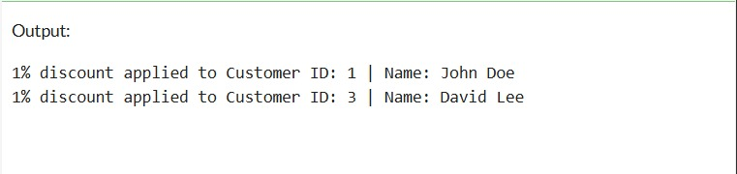

**Scenario 2:** A customer can be promoted to VIP status based on their balance.

**Question:** Write a PL/SQL block that iterates through all customers and sets a flag IsVIP to TRUE for those with a balance over $10,000.

BEGIN

FOR cust IN (SELECT customer_id, name, balance FROM customers WHERE balance > 10000) LOOP

UPDATE customers

SET IsVIP = 'TRUE'

WHERE customer_id = cust.customer_id;

DBMS_OUTPUT.PUT_LINE('Customer ID ' || cust.customer_id || ' | Name: ' || cust.name ||

' promoted to VIP');

END LOOP;

COMMIT;

END;

/

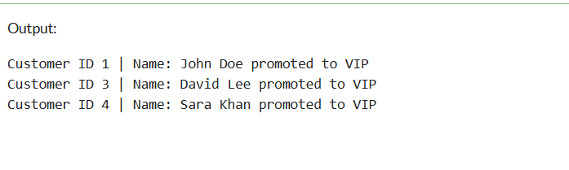

**Scenario 3:** The bank wants to send reminders to customers whose loans are due within the next 30 days.

**Question:** Write a PL/SQL block that fetches all loans due in the next 30 days and prints a reminder message for each customer.

BEGIN

FOR loan_rec IN (

SELECT l.loan_id, c.name, l.due_date

FROM loans l

JOIN customers c ON l.customer_id = c.customer_id

WHERE l.due_date <= SYSDATE + 30

) LOOP

DBMS_OUTPUT.PUT_LINE('Reminder: Loan ID ' || loan_rec.loan_id || ' for customer ' ||

loan_rec.name || ' is due on ' || TO_CHAR(loan_rec.due_date, 'DD-MON-YYYY'));

END LOOP;

END;

/

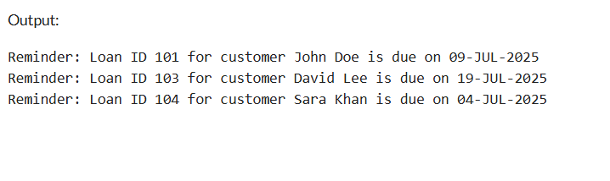

**Exercise 3: Stored Procedures**

**Scenario 1:** The bank needs to process monthly interest for all savings accounts.

**Question:** Write a stored procedure **ProcessMonthlyInterest** that calculates and updates the balance of all savings accounts by applying an interest rate of 1% to the current balance.

CREATE TABLE accounts (

account_id NUMBER PRIMARY KEY,

customer_name VARCHAR2(100),

account_type VARCHAR2(20),

balance NUMBER(10, 2)

);

CREATE TABLE employees (

emp_id NUMBER PRIMARY KEY,

emp_name VARCHAR2(100),

department VARCHAR2(50),

salary NUMBER(10, 2)

);

INSERT INTO accounts VALUES (101, 'Alice', 'savings', 10000);

INSERT INTO accounts VALUES (102, 'Bob', 'current', 15000);

INSERT INTO accounts VALUES (103, 'Charlie', 'savings', 8000);

INSERT INTO accounts VALUES (104, 'Diana', 'savings', 12000);

COMMIT;

CREATE OR REPLACE PROCEDURE ProcessMonthlyInterest AS

BEGIN

UPDATE accounts

SET balance = balance + (balance * 0.01)

WHERE account_type = 'savings';

DBMS_OUTPUT.PUT_LINE('Interest has been added to all savings accounts (1%).');

END;

/

SET SERVEROUTPUT ON;

BEGIN

DBMS_OUTPUT.PUT_LINE('ACCOUNT BALANCES BEFORE INTEREST');

FOR acc IN (SELECT * FROM accounts ORDER BY account_id) LOOP

DBMS_OUTPUT.PUT_LINE(

'Account ID: ' || acc.account_id ||

', Name: ' || acc.customer_name ||

', Type: ' || acc.account_type ||

', Balance: ' || acc.balance

);

END LOOP;

END;

/

EXEC ProcessMonthlyInterest;

BEGIN

DBMS_OUTPUT.PUT_LINE(CHR(10) || '===== ACCOUNT BALANCES AFTER INTEREST =====');

FOR acc IN (SELECT * FROM accounts ORDER BY account_id) LOOP

DBMS_OUTPUT.PUT_LINE(

'Account ID: ' || acc.account_id ||

', Name: ' || acc.customer_name ||

', Type: ' || acc.account_type ||

', Balance: ' || TO_CHAR(acc.balance, '999,999.00')

);

END LOOP;

END;

/

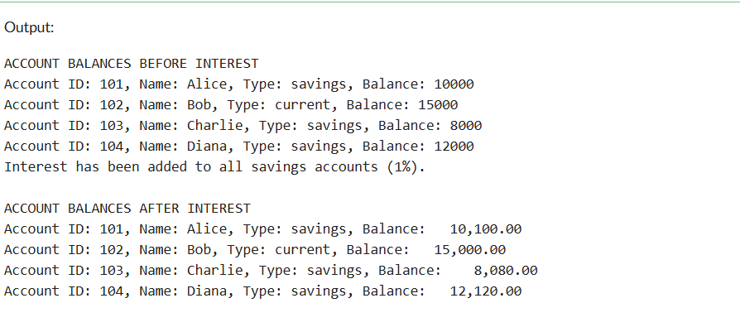

**Scenario 2:** The bank wants to implement a bonus scheme for employees based on their performance.

**Question:** Write a stored procedure **UpdateEmployeeBonus** that updates the salary of employees in a given department by adding a bonus percentage passed as a parameter.

CREATE TABLE employees (

emp_id NUMBER PRIMARY KEY,

emp_name VARCHAR2(100),

department VARCHAR2(50),

salary NUMBER(10, 2)

);

INSERT INTO employees VALUES (1, 'John', 'IT', 50000);

INSERT INTO employees VALUES (2, 'Jane', 'HR', 45000);

INSERT INTO employees VALUES (3, 'Sam', 'IT', 52000);

INSERT INTO employees VALUES (4, 'Ravi', 'Finance', 60000);

COMMIT;

CREATE OR REPLACE PROCEDURE UpdateEmployeeBonus (

p_department IN VARCHAR2,

p_bonus_pct IN NUMBER

) AS

BEGIN

UPDATE employees

SET salary = salary + (salary * p_bonus_pct / 100)

WHERE department = p_department;

DBMS_OUTPUT.PUT_LINE('Bonus of ' || p_bonus_pct || '% applied to ' || p_department || ' department.');

END;

/

BEGIN

DBMS_OUTPUT.PUT_LINE('===== SALARIES BEFORE BONUS =====');

FOR emp IN (SELECT * FROM employees ORDER BY emp_id) LOOP

DBMS_OUTPUT.PUT_LINE(

'Emp ID: ' || emp.emp_id ||

', Name: ' || emp.emp_name ||

', Department: ' || emp.department ||

', Salary: ' || emp.salary

);

END LOOP;

UpdateEmployeeBonus('IT', 10);

DBMS_OUTPUT.PUT_LINE(CHR(10) || '===== SALARIES AFTER BONUS =====');

FOR emp IN (SELECT * FROM employees ORDER BY emp_id) LOOP

DBMS_OUTPUT.PUT_LINE(

'Emp ID: ' || emp.emp_id ||

', Name: ' || emp.emp_name ||

', Department: ' || emp.department ||

', Salary: ' || TO_CHAR(emp.salary, '999,999.00')

);

END LOOP;

END;

/

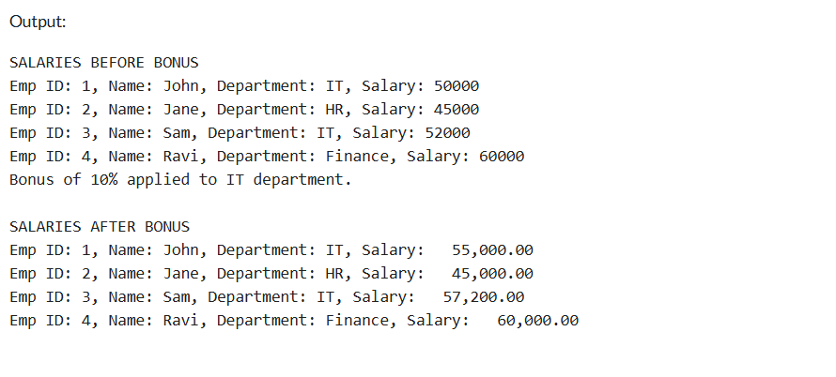

**Scenario 3:** Customers should be able to transfer funds between their accounts.

**Question:** Write a stored procedure **TransferFunds** that transfers a specified amount from one account to another, checking that the source account has sufficient balance before making the transfer.

CREATE TABLE accounts (

account_id NUMBER PRIMARY KEY,

customer_name VARCHAR2(100),

account_type VARCHAR2(20),

balance NUMBER(10, 2)

);

INSERT INTO accounts VALUES (101, 'Alice', 'savings', 10000);

INSERT INTO accounts VALUES (102, 'Bob', 'current', 15000);

INSERT INTO accounts VALUES (103, 'Charlie', 'savings', 8000);

INSERT INTO accounts VALUES (104, 'Diana', 'current', 12000);

COMMIT;

CREATE OR REPLACE PROCEDURE TransferFunds (

p_from_account IN NUMBER,

p_to_account IN NUMBER,

p_amount IN NUMBER

) AS

v_balance NUMBER;

BEGIN

SELECT balance INTO v_balance FROM accounts WHERE account_id = p_from_account FOR UPDATE;

IF v_balance < p_amount THEN

DBMS_OUTPUT.PUT_LINE('Insufficient balance in Account ' || p_from_account);

ELSE

UPDATE accounts

SET balance = balance - p_amount

WHERE account_id = p_from_account;

UPDATE accounts

SET balance = balance + p_amount

WHERE account_id = p_to_account;

DBMS_OUTPUT.PUT_LINE(''|| p_amount || ' transferred from Account ' || p_from_account || ' to Account ' || p_to_account);

END IF;

EXCEPTION

WHEN NO_DATA_FOUND THEN

DBMS_OUTPUT.PUT_LINE('One or both account IDs are invalid.');

WHEN OTHERS THEN

DBMS_OUTPUT.PUT_LINE('Unexpected error: ' || SQLERRM);

END;

/

BEGIN

DBMS_OUTPUT.PUT_LINE('BALANCES BEFORE TRANSFER ');

FOR acc IN (SELECT * FROM accounts ORDER BY account_id) LOOP

DBMS_OUTPUT.PUT_LINE(

'Account ID: ' || acc.account_id ||

', Name: ' || acc.customer_name ||

', Type: ' || acc.account_type ||

', Balance: ' || acc.balance

);

END LOOP;

TransferFunds(101, 102, 2000);

END;

/

BEGIN

DBMS_OUTPUT.PUT_LINE(CHR(10) || 'BALANCES OF TRANSFERRED ACCOUNTS ');

FOR acc IN (SELECT * FROM accounts WHERE account_id IN (101, 102) ORDER BY account_id) LOOP

DBMS_OUTPUT.PUT_LINE(

'Account ID: ' || acc.account_id ||

', Name: ' || acc.customer_name ||

', Type: ' || acc.account_type ||

', Balance: ' || TO_CHAR(acc.balance, '999,999.00')

);

END LOOP;

END;

/

